The Gl@zine 4th December 2011.

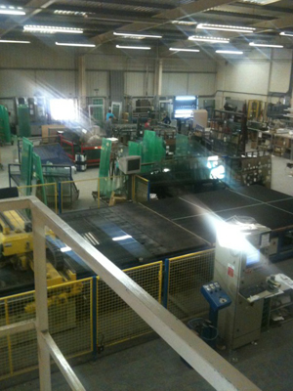
Part 3 achieved

Edgetech customer Glassteq has achieved an EN1279 Part 3 Pass with Super Spacer warm edge technology.
Jeremy Mavin, managing director of Glassteq said: “Glassteq was established seven years ago and has prided itself on supplying quality sealed units ever since. That is why we want to stay ahead of all the necessary standards for insulated glass units and the reason we were committed to achieving the EN1279 Part 3 standard on our gas filled units.
“We are thrilled that the quality systems we have in place on a day-to-day basis have been endorsed by the fact we passed this stringent standard with flying colours. The test was done in conjunction with CENSolutions and the pass rate of 0.3% was well within the required pass level of 1% or below, over 12 months.
“Now producing over 3,000 units a week Glassteq started using Super Spacer about 18 months ago to stay ahead of the changing market. The industry was moving towards Window Energy Ratings and as a result Warm Edge Technology, so we wanted to give our customers what they needed to stay ahead of their competition. I’ve worked in the window industry for 20 years so I was aware of Edgetech and how their products could further improve the performance of Glassteq’s sealed units, so when it was the right time we knew where to turn.”
www.superspacer.co.uk
.

RETURN TO HOME PAGE

